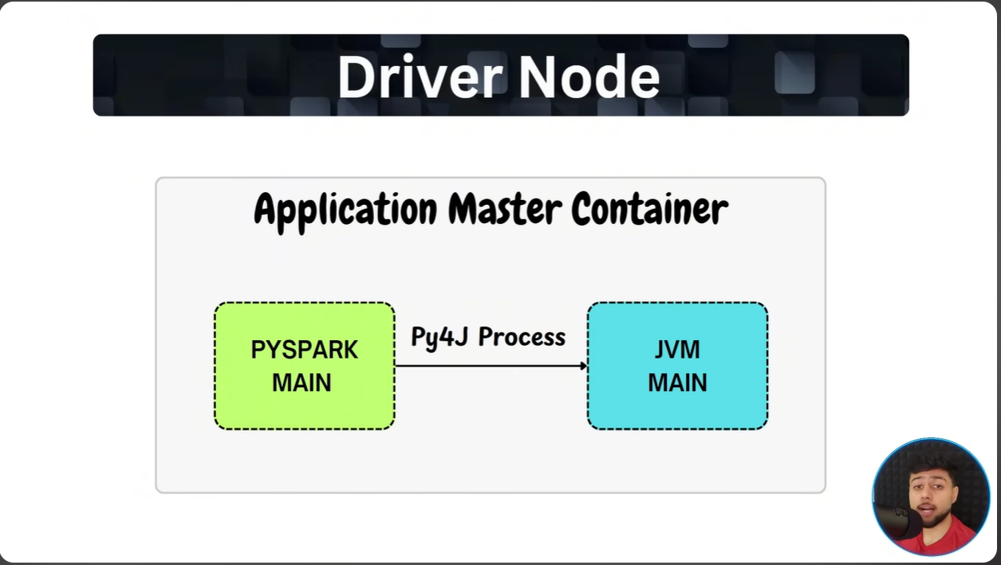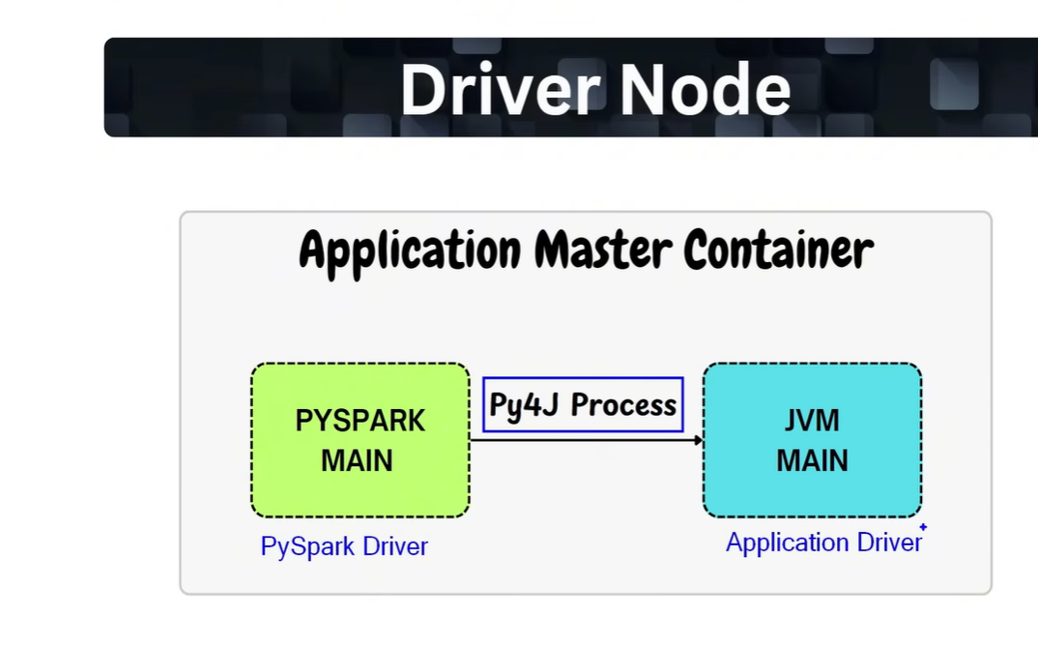
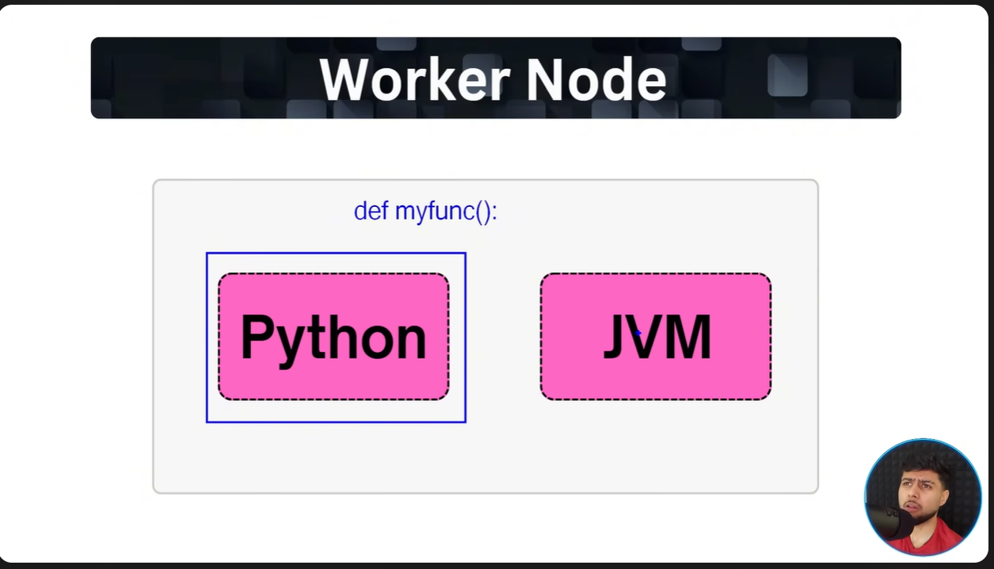

Notes: Python Interpreter is required in Worker node in case if there is any scenario of UDF in the application code . JVM in worker node is just an example , but it may also contain C/C++ compiler

